Table of Contents

1. Introduction… ......................................................................................................7
   1. Overview of the project… ..................................................................................8
2. Software requirement specification… ............................................................... 10
   1. System study .....................................................................................................10
   2. Problem definition… ........................................................................................10
   3. Requirement analysis ........................................................................................11
   4. Existing system and its Drawbacks… ...............................................................12
   5. Proposed system.................................................................................................12
   6. Requirement specification .................................................................................13
   7. About the software/tools… ................................................................................14
   8. Feasibility study .................................................................................................18
      1. Technical feasibility ........................................................................................18
      2. Economical feasibility .....................................................................................18
      3. Operational feasibility .....................................................................................19
3. System Design… ..................................................................................................20
   1. Introduction… ....................................................................................................20
   2. Module design… ................................................................................................20
   3. Users of the project .............................................................................................21
   4. Data flow Diagram… ..........................................................................................22
   5. Database design… ...............................................................................................23
   6. Use Case Diagram… ...........................................................................................29
4. Coding ....................................................................................................................31
5. System Testing .......................................................................................................38
   1. Unit testing ...........................................................................................................39
   2. Integration testing .................................................................................................39
   3. Validation testing ..................................................................................................39
   4. Output testing ........................................................................................................40
6. Implementation. .......................................................................................................40
7. Screenshots… ..........................................................................................................45

9. Conclusion… ...........................................................................................................61

10. Bibliography ..........................................................................................................63

* 1. Books… ...............................................................................................................64
  2. Websites… ...........................................................................................................64

**1. INTRODUCTION**

The project Hospital Management system includes registration of patients, storing their details into the system. The software has the facility to give a unique id for every patient and stores the details of every patient and the staff automatically. User can search availability of a doctor and the details of a patient using the id . The Hospital Management System can be entered using a username and password. It is accessible either by an administrator or receptionist. Only they can add data into the database . The data can be retrieved easily. The interface is very user-friendly. The data are well protected for personal use and makes the data processing very fast . Hospital Management System is powerful, flexible, and easy to use and is designed and developed to deliver real conceivable benefits to hospitals . Hospital Management System is designed for multi speciality hospitals, to cover a wide range of hospital administration and management processes. It is an integrated end-to-end Hospital Management System that provides relevant information across the hospital to support effective decision making for patient care, hospital administration and critical financial accounting, in a seamless flow . Hospital Management System is a software product suite designed to improve the quality and management of hospital management in the areas of clinical process analysis and activity-based costing. Hospital Management System enables you to develop your organization and improve its effectiveness and quality of work. Managing the key processes efficiently is critical to the success of the hospital helps you manage your processes .

## **1.1 OVERVIEW OF THE PROJECT**

Internet is the rapidest growing media during the past decade. Especially, website is a rapidly growing e-commerce area. This is a website for purchase the products by sitting in the home or anywhere by the gadgets.

### Module description

1. Administrator
2. User
3. Guest user

### Administrator

Admin has the overall control to this website. This section specifies all the modules that are applicable to the administrator (main functions for administrator). Contains modules to

* Registration
* Login
* Manage user
* Manage category details
* Manage product details
* Manage quantity details
* Manage type details
* View order details
* View users details
* View sales details Users

User can login using their id and password after that they can enter the home page. The user is the user with restrictions and they have the following function.

* Registration
* Login
* View Products
* Search Product
* Add to cart
* Payment Guest

### User

* View Products
* Search Product

# 2. SOFTWARE REQUIREMENT SPECIFICATION

A software requirements specification (SRS) is a detailed description of a software system to be developed with its functional and non-functional requirements. The SRS is developed based the agreement between customer and contractors. It may include the use cases of how user is going to interact with software system. The software requirement specification document consistent of all necessary requirements required for project development. To develop the software system we should have clear understanding of Software system. To achieve this we need to continuous communication with customers to gather all requirements.

## 2.1 System Study

As we all know, grocery is a very important item for every household, but

nowadays, most people are becoming too busy to go to the grocery store to buy grocery stuff. This kind of problem includes the woman who has their own career and also includes housewives.

Housewives usually do not have time to buy groceries because they are preoccupied with keeping the children and do the cooking. In addition, they also sometimes need to send and retrieve the child from school. In other words, they don’t have much time to do grocery shopping because it takes so much time. This thing can happen if they stuck in the traffic jam while going or back from the grocery store. Besides that, they also need to line up to pay for the grocery items. The other problems that are also can occur when doing the grocery shopping in usual way are consumer do not know about the item's availability in the grocery store. They will just go into a condition where they are just assuming that the items are available. The next problem that is being taken into consideration is the location of the grocery store. Sometimes, a grocery store is situated quite far from residential area which also will make consumers take a long time to get there and do the grocery shopping

## 2.2 Problem Definition

The study reveals that the male are less doing the online shopping than female. The female are more into online shopping because they enjoy doing shopping whether it is traditional shopping or e-shopping. The young generation are more often purchasing from online sites because of the revolution in the technology among the youth population and they are able to use this technology for their well-being more than other age group category. Flipkart is the shopping site which is more preferable by the youngster. There are increasing demand of online shopping because the variety of options for the consumers to choose and that to at a reasonable price and sometime even less price than the market. Electronic items were less demanded from the e-shopping but clothes are much more demanded by the consumers. There are several products which are not delivered by the shopping sites in the preferable area, it is seen that with the advancement of the technology the preference of the online shopping increases. Earlier people more uses the traditional shopping. Now also people who are not aware of the several shopping sites and not that technically advanced are less into internet for shopping. This study advanced an ideal that uses consumer value perceptions to increase our thoughtful of channel choice. Earlier work verified the key effect of perceived value has on purchase intentions, but merely concentrated on product or store value insights. This paper extends the studies while asking the questions from the consumer who are into online shopping as well as traditional shopping to rate both the channels in the terms of performance, products, time of delivery, quality and other related aspects of online and offline shopping. By accepting this approach, investigators and experts can gain valuable insights into the motivations to adopt a definite channel for shopping. A cluster of all customer communication with products, services or persons that is specific. Another concern was that the conceptual model, a theoretical context for the study of the theoretical basis of all the research on it is placed. Customer behaviour is a process of discussions with investors to buy consumer goods and consumer behaviour suggestions of the process. These are the 4 factor of consumer participation is defined as: 1. Person’s Features, 2. Standard of living, 3. Basic needs and 4. Status that directly inspire the needs. The respondents in the current study are computer user and heavier Internet users; they are updated of the technology.

### 2.3 Requirement Analysis

The local grocery stores have taken many shapes in early 20s.people had to wait in a queue for a long time and that too without any assurance that they would get the needed items. With the popularization of internet, online shopping has become a new and unique trend. From clothing to electronics, all the things are available on internet. Consumers do not even need to go to a local grocery store anymore; they can buy each and everything by just sitting in a home at anytime.

After going through e-commerce processes and real market trends, we aim at developing an online grocery store having simple and easy to use interface and secured transaction. It will provide convenience to consumer. The major goals are:

* It is user-friendly and easy to use for both consumers and vendors.

* The consumers are allowed to give feedback about any item.

* The consumers are also allowed to modify their carts individually.

* The consumers can also sell their products through online.

* They can add/remove grocery item in cart.

* The vendors are allowed to add new items in respective categories.

### 2.4 Existing System and drawbacks

The most common system is to visit the shop manually and from the available products choose items customer want to buy

* less user-friendly

* Must go to shop and select

* Time consuming

* Irregularity in price

### 2.5 Proposed System and advantages

• In the proposed system customer need not go to shop for purchasing.

* Time saver

* Deliver to home within no-time

* Customers can sell their products

* Can choose from freshly cut products to packed products.

### 2.6 Requirement Specification

Requirements analysis is critical to the success of a development project. Requirements must be actionable, measurable, testable, related to identified business needs or opportunities. And defined to a level of detail sufficient for system design. Requirements can be functional and non- functional.

### SOFTWARE CONFIGURATION

We require much different software to make the application work

efficiently. It is very important to select the appropriate software, so that the software works properly. Below is the software that is required to make the new system.

OPERATING SYSTEM : WINDOWS 2007 OR ABOVE, LINUX

WEB SERVER : WampServer 2.1

ENVIRONMENT : PHP

FRONT END : HTML, CSS, JavaScript, Bootstrap

BACKEND : PHP, MICROSOFT SQL SERVER 5.1

BROWSER : Google Chrome or Mozilla Firefox

### HARDWARE CONFIGURATION

The selection of hardware is very important in the existence and

proper working of any software. When selecting hardware, the size and capacity requirements are also important. Below is some of the hardware that is required by the system

PROCESSOR : PENTIUM 4 or Above

CLOCK SPEED : 500 MHZ SYSTEM BUS : 32 BIT

RAM : 1 GB or Above

HDD : 40 GB

#### 2.7. ABOUT THE SOFTWARE/TOOLS

To develop the project, the tools chosen are Wamp as server, MYSQL as back end, PHP as language and operating system as Windows XP. These tools are specified by the client. The organization's standard is also considered. Their software development is on the basis of latest tools and technology

# FRONT END DESCRIPTION

## PHP

PHP is an acronym for "PHP: Hypertext Pre-processor". PHP is a widely-used, open-source scripting language. PHP scripts are executed on the server. PHP is free to download and use. PHP is an amazing and popular language. It is powerful enough to be at the core of the biggest blogging system on the web. It is deep enough to run the largest social network. It is also easy enough to be a beginner’s first server-side language.

PHP files can contain text, HTML, CSS, JavaScript, and PHP code. PHP code are executed on the server, and the result is returned to the browser as plain HTML. PHP files have extension " php ". PHP can generate dynamic page content. PHP can create, open, read, write, delete, and close files on the server. PHP can collect form data. PHP can send and receive cookies. PHP can add, delete, and modify data in your database. PHP can be used to control user-access. PHP can encrypt data. With PHP you are not limited to output HTML. You can output images, PDF files, and even flash movies. You can also output any text, such as XHTML and XML.

### Advantages

* PHP runs on various platforms (Windows, Linux, UNIX, Mac OS X, etc.)
* PHP is compatible with almost all servers used today (Apache, IIS, etc.)
* PHP supports a wide range of databases
* PHP is free
* PHP is easy to learn and runs efficiently on the server side

# OPERATING SYSTEM

## WINDOWS 7

Windows 7 (codenamed Vienna, formerly Blackcomb) is a personal computer operating system developed by Microsoft. It is a part of the Windows NT family of operating systems. Windows 7 was released to manufacturing on July 22, 2009, and became generally available on October 22, 2009, less than three years after the release of its predecessor, Windows Vista. Windows 7's server counterpart, Windows Server 2008 R2, was released at the same time. Windows 7 was primarily intended to be an incremental upgrade to the operating system intending to address Windows Vista's poor critical reception while maintaining hardware and software compatibility. Among Windows 7's new features are advances in touch and handwriting recognition, support for virtual hard disks, improved performance on multi-core processors, improved boot performance, Direct Access, and kernel improvements. Window management in Windows 7 has several new features: Snap maximizes a window when it is dragged to the top of the screen. Dragging windows to the left or right edges of the screen allows users to snap software windows to either side of the screen, such that the windows vertically take up half the screen. When a user moves windows that were snapped or maximized using Snap, the system restores their previous state. Snap functions can also be triggered with keyboard shortcuts. Shake hides all inactive windows when the active window’s title bar is dragged back and forth rapidly (metaphorically shaken).

# DESCRIPTION OF DATABASE

## MYSQL

MySQL is the most popular Open Source Relational SQL Database Management System. MySQL is one of the best RDBMS being used for developing various web-based software applications. MySQL is developed, marketed and supported by MySQL AB, which is a Swedish company. This tutorial will give you a quick start to MySQL and make you comfortable with MySQL programming.

A database is a separate application that stores a collection of data. Each database has one or more distinct APIs for creating, accessing, managing, searching and replicating the data it holds.

Other kinds of data stores can also be used, such as files on the file system or large hash tables in memory but data fetching and writing would not be so fast and easy with those type of systems.

Nowadays, we use relational database management systems (RDBMS) to store and manage huge volume of data. This is called relational database because all the data is stored into different tables and relations are established using primary keys or other keys known as Foreign Keys. A Relational Database Management System (RDBMS) is a software that −

* Enables you to implement a database with tables, columns and indexes.
* Guarantees the Referential Integrity between rows of various tables.
* Updates the indexes automatically.

Interprets an SQL query and combines information from various tables

RDBMS Terminology

Before we proceed to explain the MySQL database system, let us revise a few definitions related to the database.

* Database − A database is a collection of tables, with related data.

* Table − A table is a matrix with data. A table in a database looks like a simple spreadsheet.

* Column − One column (data element) contains data of one and the same kind, for example the column postcode.
* Row − A row (= tuple, entry or record) is a group of related data, for example the data of one subscription.
* Redundancy − Storing data twice, redundantly to make the system faster.

* Primary Key − A primary key is unique. A key value cannot occur twice in one table. With a key, you can only find one row.
* Foreign Key − A foreign key is the linking pin between two tables.

* Compound Key − A compound key (composite key) is a key that consists of multiple columns, because one column is not sufficiently unique.
* Index − An index in a database resembles an index at the back of a book.

* Referential Integrity − Referential Integrity makes sure that a foreign key value always points to an existing row.

### MySQL Database

MySQL is a fast, easy-to-use RDBMS being used for many small and big businesses. MySQL is developed, marketed and supported by MySQL AB, which is a Swedish company. MySQL is becoming so popular because of many good reasons −

* MySQL is released under an open-source license. So you have nothing to pay to use it.

* MySQL is a very powerful program in its own right. It handles a large subset of the functionality of the most expensive and powerful database packages.
* MySQL uses a standard form of the well-known SQL data language.
* MySQL works on many operating systems and with many languages including PHP, PERL, C, C++, JAVA, etc.
* MySQL works very quickly and works well even with large data sets.

* MySQL is very friendly to PHP, the most appreciated language for web development.

* MySQL supports large databases, up to 50 million rows or more in a table. The default file size limit for a table is 4GB, but you can increase this (if your operating system can handle it) to a theoretical limit of 8 million terabytes (TB).
* MySQL is customizable. The open-source GPL license allows programmers to modify the MySQL software to fit their own specific environments.

## 2.8 FEASIBILITY STUDY

### 2.8.1 Technical feasibility

The assessments of technical feasibility centers on the existing system and to what extent it can support the proposed addition. This was based on an outline design of system requirements in turns of inputs, files, programs, procedures, and staff. It involves financial considerations to accommodate technical enhancement.

### 2.8.2 Economic feasibility

Economic analysis is the most frequently used method for evaluating the effectiveness of a candidate system. It is more commonly known as cost benefit analysis, the procedure to determine the benefits and saving that are expected from a candidate system and compare them with costs. If the benefits outweigh costs then a decision is made to design and implement the system. Otherwise make alterations in the proposed system.

### 2.8.3 Operational Feasibility

The development of this e-grocery portal will make the people who really

want to save time while doing the grocery shopping is much easier and also can do it fast. This e- grocery portal also can be used anywhere if there is an Internet connection. By purchasing the grocery items through this system, they do not need to go to the grocery store to do the grocery shopping and do not need to queue to make payment. The technique that we choose to develop this system, OOAD is the best choice because this technique will produce a system that is more flexible, modifiable and easily maintainable systems.

For the conclusion, for us, this e-grocery system is one of the convenient ways for the customers because ask, we know nowadays, mostly every household have internet and just by using the Internet connection, customers can purchase grocery items and the grocery items will deliver straight to their home by the store’s delivery person.

By using this e-grocery system, it will make a hassle-free shopping and for the future work, this portal can be expanded not only used for the grocery items but also for other product such as hardware product, clothes or gift store. But the system will be needed to be improved to make sure that it will give the best service.

Besides that, the portal also can be added any advertisement or promotion about some product that can attract the user to buy and also can put news updates or future event about the store activity. For example, if the sore will have some joint venture with other store, the news can be shown there. The other things that can be added in the portal are visitor counter and link to the other important website or online shop such as eBay or Amazon.com.

# 3. SYSTEM DESIGN

## INTRODUCTION

System designing is the process of defining the architecture, components,

modules, interfaces and data for a system to satisfy specified requirements. It is a solution to a

“how to” approach compared to system analysis which is a “what is” orientation. It translates the system requirements into ways of making them operational. The design phase focuses on the detailed implementation of the system recommended in the feasibility study.

The system which is in making is developed by working on two different modules and combining them to work as a single unit. That single unit is the one which is known as the new software. We go through the different design strategies to design the system we are talking about. In the input design we decide which type of input screens are going to be used for the system in making. In the output design we decide the output screens and the reports that will be used to give the output and in the database design we decide what all tables will be required and what all fields will be there in those tables. Each of them is discussed briefly below.

3.1 MODULE DESIGN

## MODULE DESCRIPTION

1. Administrator

1. Customer

## 3.2 Organization profile

### ADMIN MODULE

An admin module in this system will make sure that the user that is acting as an admin of the system can cooperate and easier to manage.

This admin module also will make grocer who is using this system can easily manage their product such as adding product, edit the product price, create new catalogs and category, viewing customers order, passing customers order to the employee module and also can keep track with business flow.

There are two system management that admin will control. First, the product management system and second, purchase management system. For the product management system, admin can edit all the product details and also can add a new category and add new catalog.

For the purchase, management system, admin can view all the purchasing process that is made by the customers and admin also will take action when customers made an order by viewing the order in here.

Besides that, this module also will cooperate with the other two modules to complete the system. It will get some parameter from the user module and pass it to the employee module.

### USER MODULE

A module description provides detailed information about the module and its supported components, which is accessible in different manners. The included description is available by reading directly, by generating a short html-description, or by making an environment check for supported components to check if all needed types and services are available in the environment where they will be used. This environment check could take place during registration/installation or during a separate consistency check for a component**.**

Login: This module has a drop down list box from where we have to select.

Registration: This extension enables you to manage both Login and registration from a module itself without having the user to go the registration page.

Product Search: The module allows you to implement sophisticated product search functionality with just a few clicks of the mouse. This feature can be added to any web page via the Module manager:

Purchase Cart System: The Grocery Cart provides shopping cart functionality that is tightly integrated with the Store database. This easy-to-use tool allows you to manage the content of your Cart. It provides a new way of reporting and storing purchase transactions that will be familiar to anyone who shops on the web using a virtual shopping cart.

Feedbacks**:** The Feedback module allows you to create and conduct surveys to collect feedback. Unlike the Survey tool it allows you to write your own questions, rather than choose from a list of pre-written questions and unlike the Quiz tool, you can create non-graded questions. The Feedback activity is ideal for the likes of course or teacher evaluations.

#### 3.3 USERS OF THE PROJECT

Admin **:** Admin also known as webmasters, web developers or network and computer system administrators, are responsible for all aspects of keeping website content and design fresh, backed up, and fully functional. They typically work closely with clients to make sure they understand how they want their websites to look and function. Depending on their specific role, they may also be responsible for making sure local networks are functioning properly as well.

Users**:** Users are the customers who use the system website product without the technical expertise required to fully understand it. Power users use advanced features of programs, though they are not necessarily capable of computer programming and system administration.

Guest User**:** They are also customers who can view and search products. They cannot buy the products without registering.

#### 3.4 DATA FLOW DIAGRAM

A DFD is a graphical representation that depicts information flow and the

transforms that are applied as data move from input to output. The basic form of a DFD is also known as a Data flow graph or a bubble chart.

DFD may be used to represent a system or software at any level of

abstraction. DFDs can be partitioned into levels that represent increasing information flow and functional detail. A level 0 DFD, also called a fundamental system model or a context model, represents the entire software element or a single bubble with input and output data indicated by incoming and outgoing arrows, respectively. A level 1 DFD may contain five or six bubbles with interconnection arrows. Each of the processes represented at level 1 is a sub function of the overall system depicted in the context model.

##### DFD Notations

It represents a process or transform that is applied to data.

It represents data store-stored information that is used by software

It represents a source or destination

It represents a flow of data, that is, a data stream.

As illustrated in the above figure, the circle and or the bubble represent the

transformation process, and the label inside the bubble describes the process, using an active verb to do so. Data flows or directed lines that identify the input data flows and output data flows at each process bubble. Data storage represented by an open-ended rectangle with a label that identifies the data store or file. The square is labeled to identify an external entity that is source or destination of a data flow.

#### 3.5 DATABASE DESIGN

Database design is the logical form of design of data storage in the form of records in a particular structure in the form of tables with fields which is not transparent to the normal user but it actually act as the backbone of the system. As we know database is a collection of which helps the system to manage and store data is called database management system. Database management system builds some form of constraints like integrity constraints, i.e., the primary key or unique key and referential integrity which help to keep data structure storage and access of data from tables efficiently and accurately and take necessary steps to concurrent access of data and avoid redundancy of data in tables by normalization criterions.

Normalization is the method of breaking down complex table structures into simple table structures by using certain rules thus reduce redundancy and inconsistency and disk space usage and thus increase the performance of the system or application which is directly linked to the database design and also solve the problems of anomalies.

There are different forms of normalization, some are:

* First normal form (1NF)
* Second normal form (2NF)
* Third normal form (3NF)
* Boyce Cod normal form
* Forth normal form (4NF)
* Fifth normal form (5NF)

The data base design of the new system is in second normal form and every non key attribute is functionally depend only on the primary key. The master and transaction tables and their structure are shown below.

**Level 0**

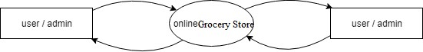

**Level 1**

**User:**

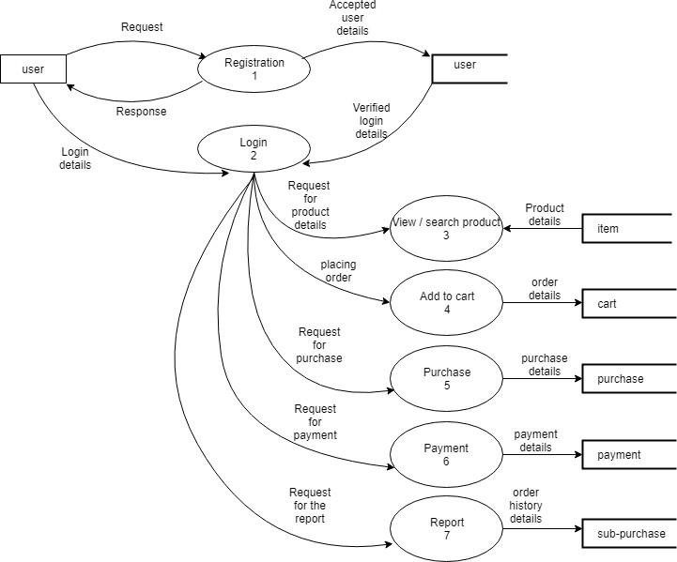

**Admin:**

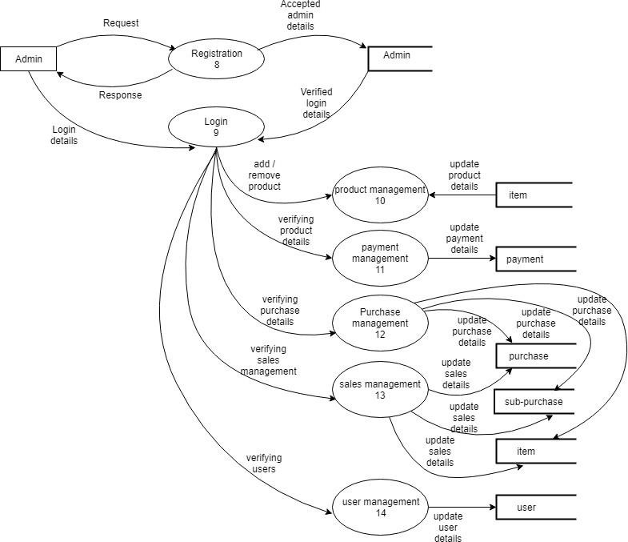

##### Table Structure

Table: [category_tbl](http://localhost/phpmyadmin/sql.php?db=db_store&table=category_tbl&token=cefb1bace175cbe6502c83dab3cb19f9)

|  |  |  |  |
| --- | --- | --- | --- |
| Column Name | Data Type | Description | Constraint |
| Sl_no | int(11) | Serial number | Primary key |
| Category_id | varchar(20) | Category Id | Foreign key |
| Category_name | varchar(30) | Category name |  |
| Category_info | varchar(20) |  |  |

Table: batch_tbl

|  |  |  |  |
| --- | --- | --- | --- |
| Column Name | Data Type | Description | Constraint |
| Sl_no | int(11) | Serial number | Primary key |
| Category_name | varchar(30) | Category name |  |
| Batch_id | varchar(30) | Batch id | Foreign key |
| Batch_name | varchar(25) | Batch name |  |
| Batch_Info | varchar(20) | Batch Information |  |

Table: proimg_tbl

|  |  |  |  |
| --- | --- | --- | --- |
| Column Name | Data Type | Description | Constraint |
| Sl_no | int(11) | Serial number | Auto increment |
| Product_Name | varchar(20) | Product Name | Foreign key |
| Path | Varchar(200) | Product Image |  |

Table: comment_tbl

|  |  |  |  |
| --- | --- | --- | --- |
| Column Name | Data Type | Description | Constraint |
| User_mail | Varchar(25) | User Id | Primary key |
| Comment | Varchar(30) | Comments |  |

Table : product_tbl

|  |  |  |  |
| --- | --- | --- | --- |
| Column Name | Data Type | Description | Constraint |
| Sl_no | int(11) | Serial number | Primary Key |
| Category_name | varchar(30) | Category name | Foreign key |

|  |  |  |  |
| --- | --- | --- | --- |
| Batch_name | varchar(25) | Batch name | Foreign key |
| Product_id | varchar(20) | Product Id | Foreign key |
| Product_Name | varchar(20) | Product Name |  |
| Product_info | Varchar(20) | Product Information |  |
| Product_type | Varchar(50) | Product Information |  |
| Product_mrp | int(11) | Product MRP |  |
| Product_price | Int(11) | Selling price |  |
| Display_Type | Varchar(20) | Display Details |  |

Table: Order_tbl

|  |  |  |  |
| --- | --- | --- | --- |
| Column Name | Data Type | Description | Constraint |
| Order_id | Int(11) | Order Id | Foreign key |
| Product_id | Varchar(50) | Product id | Foreign key |
| Product_price | int(11) | Product Price |  |
| Product_qnty | int(11) | Quantity |  |
| User_mail | Varchar(50) | User Id | Foreign key |
| Order_date | Date | Date of order |  |

Table: Shipment_tbl

|  |  |  |  |
| --- | --- | --- | --- |
| Column Name | Data Type | Description | Constraint |
| Sl_no | Int(11) | Serial number | Auto increment |
| User_id | Varchar(30) | User Id |  |
| Ship_name | Varchar(30) | Shipment name |  |
| Ship_phno | Varchar(10) | Shipment phone number |  |
| Ship_address | Varchar(30) | Shipment address |  |
| Ship_line | Varchar(30) | Shipment line address |  |
| Ship_city | Varchar(30) | Shipment city |  |
| Ship_pincode | Varchar(6) | Shipment pincode |  |
| Ship_state | Varchar(30) | Shipment state |  |
| Ship_country | Varchar(30) | Shipment country |  |
| Bill_name | Varchar(30) | Bill name |  |
| Bill_mail | Varchar(50) | Bill mail id |  |
| Bill_phno | Varchar(10) | Bill phone number |  |

Table: userregis_tbl

|  |  |  |  |
| --- | --- | --- | --- |
| Column Name | Data Type | Description | Constraint |
| Sl_no | Int(11) | Serial number | Auto increment |
| User_desig | Varchar(10) | User designation |  |
| User_fname | Varchar(30) | User first name |  |
| User_mname | Varchar(10) | User middle name |  |
| User_lname | Varchar(30) | User last name |  |
| User_mail | Varchar(50) | User mail id | Foreign key |
| User_pswd | Varchar(30) | User password |  |
| User_phno | Varchar(10) | User phone number | Primary key |
| User_home | Varchar(30) | User home address |  |
| User_pin | Int(11) | User home pincode |  |
| User_city | Varchar(30) | User home city |  |
| User_state | Varchar(30) | User state |  |
| User_country | Varchar(10) | User country |  |

Table: contact_tbl

|  |  |  |  |
| --- | --- | --- | --- |
| Column Name | Data Type | Description | Constraint |
| User_name | Varchar(25) | User name |  |
| User_mail | varchar(30) | User mail id | Foreign key |
| User_phno | varchar(10) | User phone number | Primary |
| Enquiry | varchar(100) | Enquiry from user |  |

3.6 USECASE DIAGRAM

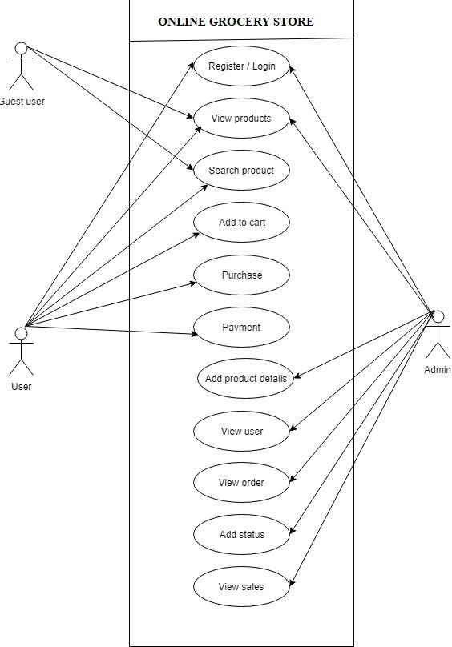

# 4. CODING

## Index.php

<?php

//connection

$con=mysql_connect("localhost","root",""); mysql_select_db("db_store",$con); include ('head.php');

//google login info require_once('settings.php'); require_once('google-login-api.php'); if(isset($_GET['code'])) { try { $gapi = new GoogleLoginApi();

// Get the access token

$data = $gapi->GetAccessToken(CLIENT_ID, CLIENT_REDIRECT_URL,

CLIENT_SECRET, $_GET['code']);

// Get user information

$user_info = $gapi->GetUserProfileInfo($data['access_token']);

// Now that the user is logged in you may want to start some session variables

$_SESSION['logged_in'] = 1;

// You may now want to redirect the user to the home page of your website

} catch(Exception $e) { }

}?>

<div id="tab-featured-0" class="tab-pane">

<div class="products-carousel">

<?php

$sqlcategory=mysql_query("select product_tbl.Product_Name,Product_Id,Product_MRP, Product_Price,Path from product_tbl ,proimg_tbl where Product_tbl.Product_Id= proimg_tbl.Product_Name and proimg_tbl.Sl_No in(select max(Sl_No) from proimg_tbl group by Product_Name) and Display_Type='featured' order by product_tbl.sl_no limit 10");

$numcategory=mysql_num_rows($sqlcategory);

for ($i=0; $i <$numcategory ; $i++) { $rowcategory=mysql_fetch_array($sqlcategory);?>

<div class="product-layouts">

<div class="product-thumb transition">

<div class="image"><a href="items.php?id=<?php echo

$rowcategory['Product_Id'] ?>"> <img class="image" width="202px" height="202px" src='<?php echo $rowcategory["Path"]; ?>' title="<?php echo $rowcategory["Product_Name"]; ?>" alt="<?php echo $rowcategory["Product_Name"]; ?>"/> </a>

<div class="sale-icon">Sale</div></div>

<div class="thumb-description">

<div class="caption">

<h4><a href="items.php?id=<?php echo $rowcategory['Product_Id'] ?>"><?php echo

$rowcategory["Product_Name"]; ?></a></h4></div>

<div class="button-wrapper"><div class="price">&#x20b9; <?php echo

$rowcategory["Product_Price"]; ?> <span class="price-old">&#x20b9;<?php echo $rowcategory["Product_MRP"]; ?></span></div></div></div></div></div>

<?php

}?> </div></div><div class="ttservicemerge"><div class="block_content" id="footerservice"><div class="ttshipping"><div class="ttcontent_inner"> <div class="service"><div class="ttshipping_img service-icon"></div>

<div class="service-content"><div class="service-title">Delivery</div>

<div class="service-desc">Door to door delivery</div></div></div></div>

</div>

<div class="ttsupport">

<div class="ttcontent_inner"><div class="service"><div class="ttsupport_img service- icon"></div><div class="service-content"><div class="service-title">24x7 Support</div><div class="service-desc">in safe hands</div></div></div>

</div></div>

<divclass="ttsaving"><divclass="ttcontent_inner"><divclass="service"><div class="ttsaving_img service-icon"></div><div class="service-content">

<div class="service-title">Big Saving</div><div class="service-desc">at lowest price</div></div></div></div>

</div>

<div class="ttmoneyback"><div class="ttcontent_inner">

<div class="service"><div class="ttmoneyback_img service-icon"></div>

<div class="service-content"><div class="service-title">Money Back</div>

<div class="service-desc">Easy to return</div></div></div></div></div>

</div></div>

<div class="footer-column footer-right-cms col-sm-3"><aside id="footer-right"> <div class="html-content"><div class="box-content"><div class="contact-us">

<h5>Contact Us</h5><ul class="list-unstyled"><li class="contact"><i class="fa faphone"></i><span class="phone">0480 2733573</span></li>

<li class="contact"><i class="fa fa-mobile"></i><span class="phone">828 995 5543</span></li><li class="email"><i class="fa fa-envelope-o"></i><span class="email- address">

<ahref="mailto:josephsooraj33@gmail.com">admin@Thakali.in</a></span></li>

</ul></div></div></div>

<h5>Chat with us</h5><div class="html-content"><div class="box-content">

<iframe width="350" align="footer-right" height="430" src="https://console.dialogflow.com/api- client/demo/embedded/66357575-9878-4044-a440- 6bf428de5a1a"></iframe></div></div></aside> </div>

Signin.php

<?php if(!isset($_COOKIE['user1'])){include('header.php'); ?>

<title>Thakali.in - Login</title>

<div class="contact-wrapper"><div class="contact-wrapper-inner">

<div class="container"><div class="row"><div class="col-md-8 col-md-offset-2">

<div class="contact-form-wrapper"><div class="row"><div class="col-md-12">

<div class="contact-title"><h3>Sign In Your Account</h3></div></div></div>

<div class="row"><div class="col-md-6 col-xs-12"><div class="post-comment-form- group"><form method="post"><div class="row"><div class="col-md-12"><strong><input type="text" name="text" placeholder="Enter Mail Id / Phone Number*" id="txtuser" class="form- control" style="border-radius: 10px"></strong></div></div><br><div class="row"><div class="col-md-12">

<strong><input type="password" name="password" id="txtpsswd" placeholder="Password*" class="form-control" style="border-radius: 10px"></strong></div></div><br><div class="row"><div class="col-md-6">

<font color="white"><input type="submit" id="btnsub" value="Sign In" name="signin" class="btn btn-block btn-brand btn-lg" style="border-radius: 50px; background-color: green "></font></div><br><div class="col-md-6">

<a href="<?php echo'https://accounts.google.com/o/oauth2/auth?scope=' . urlencode('https:/[/www.googleapis.com/auth/userinfo.profile](http://www.googleapis.com/auth/userinfo.profile) https:/[/www.googleapis.com/auth/userinfo.email](http://www.googleapis.com/auth/userinfo.email) https:/[/www.googleapis.com/auth/plus.me')](http://www.googleapis.com/auth/plus.me%27)) . '&redirect_uri=' . urlencode(CLIENT_REDIRECT_URL) . '&response_type=code&client_id=' . CLIENT_ID . '&access_type=online' ?>"> <input type="button" value="Login with Google" class="btn btn-danger"></a></div></div></form></div>

<a href="frgtpswd.php" class="pull-right"><h5>Forgot Password?</h5></a>

<div class="row"><div class="col-md-12"><div class="askAccount-wrapper text-center"><a href="signup.php"><h3>Haven't An Account?</h3></a>

</div></div></div></div></div></div></div></div></div></div></div>

<?php if (isset($_POST['signin']))

{ $uid=$_POST['text']; $password=$_POST['password'];

$sqlcategory=mysql_query("select * from userregis_tbl where User_mail='$uid' or

User_phno='$uid' && User_pswd='$password'"); $numcategory=mysql_num_rows($sqlcategory); if($numcategory>0)

{ $rowcategory=mysql_fetch_array($sqlcategory); setcookie("user1",$rowcategory["User_fname"],time() + (86400 * 30), "/"); setcookie("user_mail",$rowcategory["User_mail"],time() + (86400 * 30), "/"); header("Locati[on:htt](http://localhost/rawkart/index.php)p:[//localhost/rawkart/index.php")](http://localhost/rawkart/index.php);setcookie("user1", "", time() - 3600);

}else{ echo "<script>alert('Invalid Entry')</script>";}

}include('footer.php'); }else{header("location:index.php");}?>

# 5. SYSTEM TESTING

System testing is the stage of implementation, which is aimed at ensuring that the system works accurately and efficiently before live operation commences. Testing is vital to the success of the system. An elaborate testing of data is prepared and the system is tested using the test data. While testing error noted and corrections are made. The users are trained to operate the developed system. Testing steps:

* Unit Testing
* Integration Testing
* Validation Testing
* Output Testing

## 5.1. UNIT TESTING

In this testing we test each module, individually and integrate the overall system. Unit testing focuses verification efforts on the smaller unit of software design in the module. This is also known as ‘module’ testing. The modules of the system are tested separately. The testing is carried out during programming stage itself. In this testing step each module is found to work satisfactory as regard to the expected output from the module. There are some validation checks for verifying the data input given by the user. It is very easy to find error and debug the system.

## 5.2. INTEGRATION TESTING

Data can be lost across an interface; one module can have an adverse effect on the other sub functions when combined by, may not produce the desired major functions. Integrated testing is the systematic testing for constructing the uncover errors within the interface. This testing was done with simple data by transferring free messages before running if officially.

## 5.3. VALIDATION TESTING

At the culmination of Black Box testing, software is completely assembled as a package, interface errors have been uncovered and corrected and final series of software tests, validation test begins. Validation testing can be defined in many ways but a simple definition is that validation succeeds when the software functions in a manner that can be reasonably accepted by the customer.

After validation test has been conducted one of the two possible conditions exits. ○ The performance characteristics confirm to specification and are accepted.

○ A deviation from specification is uncovered and a deficiency list is created.

## 5.4. OUTPUT TESTING

After performing the validation testing, the next step is output testing of the proposed system since no system could be useful if it doesn’t produce the required data in the specific Format. The output displayed or generated by the system under consideration is tested by, asking the user about the format displayed. The output format on the screen is found to be correct as the format was designed in the system according to the user needs. Hence the output testing doesn’t result in any correction of the system.

## 6. IMPLEMENTATION

Implementation is the stage in the project where the theoretical design is turned into working system and is giving confidence on the new system for the users that it will work efficiently and effectively. It involves careful planning, investigation of the current system and its constraints on implementation, design of methods to achieve the changeover, an evaluation of change over methods. Apart from planning major task of preparing the implementation are education and training of users. The more complex system is being implemented, the more involved will be the system analysis and design effort required just for implementation.

An implementation co-ordination committee based on politics of individual

organization has been appointed. The implementation process begins with preparing a plan for the implementation of the system. According to this plan, the activities are to be carried out, discussions made regarding the equipment and resources and the additional equipment has to be acquired to implement the new system.

Implementation is the final and important phase. The most critical stage in

achieving a successful new system and in giving the user’s confidence that the new will work be effective. The system can be implemented only after through testing is done and if it found to working according to the specification. This method also offers the greatest security since the old system can take over if the errors are found or inability to handle certain type of transactions while using the new system.

Depending on the size of the organization and its requirements the implementation is divided into two parts

* Stage implementation
* Direct implementation

## IMPLEMENTATION PROCEDURES

The major implementation procedures are,

* Test Plans
* Training
* Equipment Installation
* Conversion

* 1. Test Plans:

The implementation of a computer-based system requires that test data be prepared

and that the system and its elements be tested in a planned, structured manner. The computer program component is a major subsystem of the computer-based information system, and particular attention should be given to the testing of this system element as it is developed.

* 1. Training:

The purpose of the training is to ensures that all the personnel who are to be

associated with the computer-based business system possess the necessary knowledge skills, Operating, Programming, and user personnel are trained using reference manuals as training aids.

### 6.1 Programmer Training

Programmers are assigned to the computer based business system project at the

beginning of the development phase. The programmer’s reference manual informs an experienced programmer, unfamiliar with the system, about all the aspects of the computer program. The manual should enable this person to (1) understand existing program components; (2) modify existing program components; and (3) write new program components.

### 6.2 Operator Training

If new equipment is to be installed, operator training is completed in conjunction

with its installation and checkout. If new equipment is not required for the computer-based system, operators still must become familiar with the operational requirements of the new system. Different kinds of personnel may be involved in the operation of the system, such a computer operators, console operators, and data entry operators. Training programs for operators are scheduled to coincide with the needs of the computer-based business system as it is developed tested and approaches operational status. Users, analysts and programmers may participate in the training of operators.

### 6.3 User Training

After the system is implemented successfully, training of the user is one of the

most important subtasks of the developer. Even well designed and technically elegant systems can succeed or fail, because of the way they are operated and used. For this purpose user manuals are prepared and handled over to the user to operate and developed system. Thus the users are trained to operate the developed system. Both the hardware and software securities are made to run the developed system successfully in future. In order to put new application system into use, the following activities were taken care of:

* Preparation of user and system documentation
* Conducting user training with demo and hands on
* Test run for some period to ensure smooth switching over the system

The users are trained to use the newly developed functions. User manual describing the Procedures for using the functions listed on menu and circulated to all the users. It is confirmed that the system is implemented up to users need and expectations.

* 1. Equipment Installation:

Equipment vendors can provide the specification for equipment installation. They

usually work with the project’s equipment installation team in planning for adequate space, power, and light and a suitable environment. After a suitable site has been completed, the computer equipment can be installed. Although equipment normally is installed by the manufacturer, the implementation team should advice and assist. Participation enables the team to aid in the installation and, more importantly, to become familiar with the equipment.

* 1. Conversion:

Conversion is the process of performing all of the operations that result directly in

the turnover of the new system to the user. Conversion has two parts:

1. The creation of a conversion plan at the start of the development phase and the implementation of this plan throughout the development phase.
2. The creation of the system change over plan to the end of the development phase and the implementation of the plan at the beginning of the operating system.

# SECURITY MECHANISMS

## ❖ Identification

It is scheme for identifying persons to the system based on ‘something you know’

such as password. In the Auction Site, both the auctioneer and the bidder are given passwords for identification purpose during registration process.

## ❖ Access Control

Controlling access to computer databases is essential. In the Auction Site only the administrator has given the access to the tables.

## ❖ Audit Control

Auditing must be supported at all levels of management. Audit controls protect system from external security breaches and internal fraud or embezzle men. Various software programs are available to help in the audit function.

# **7.** SCREEN SHOTS

Index.php

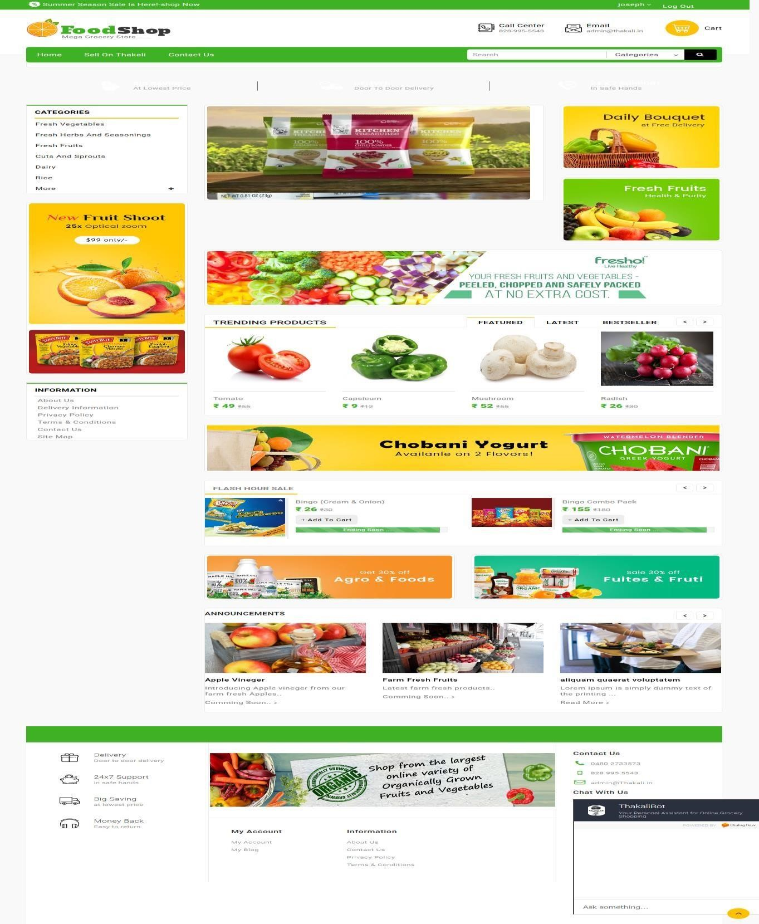

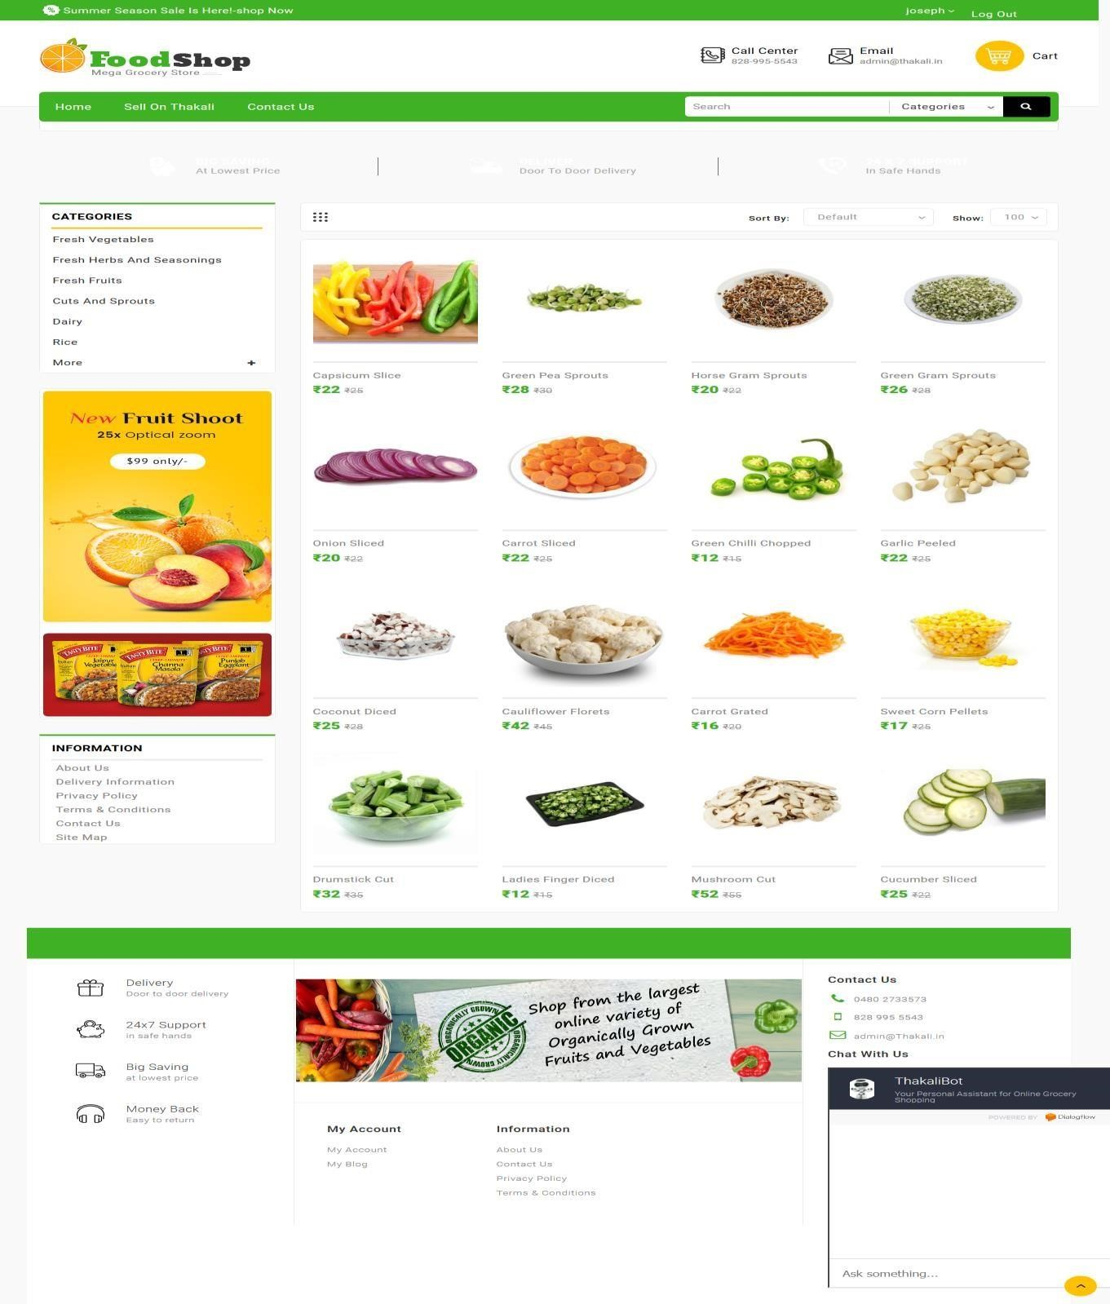

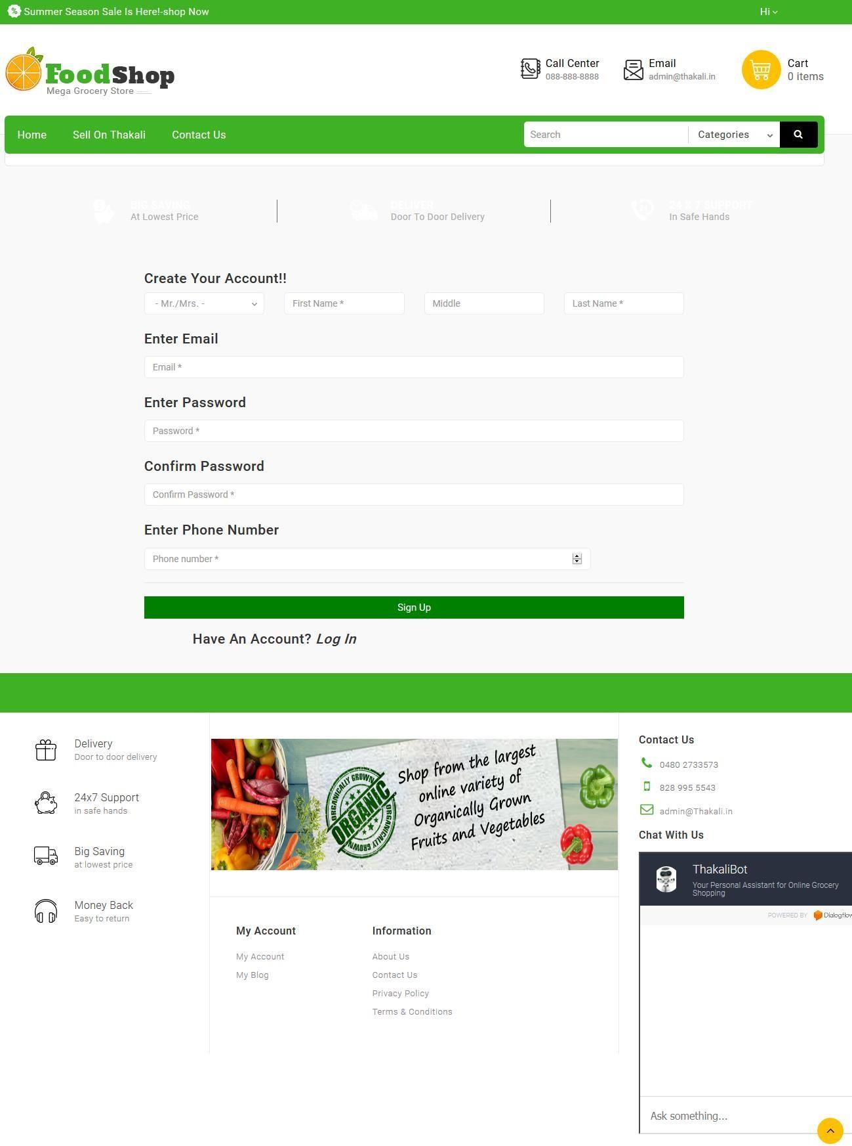

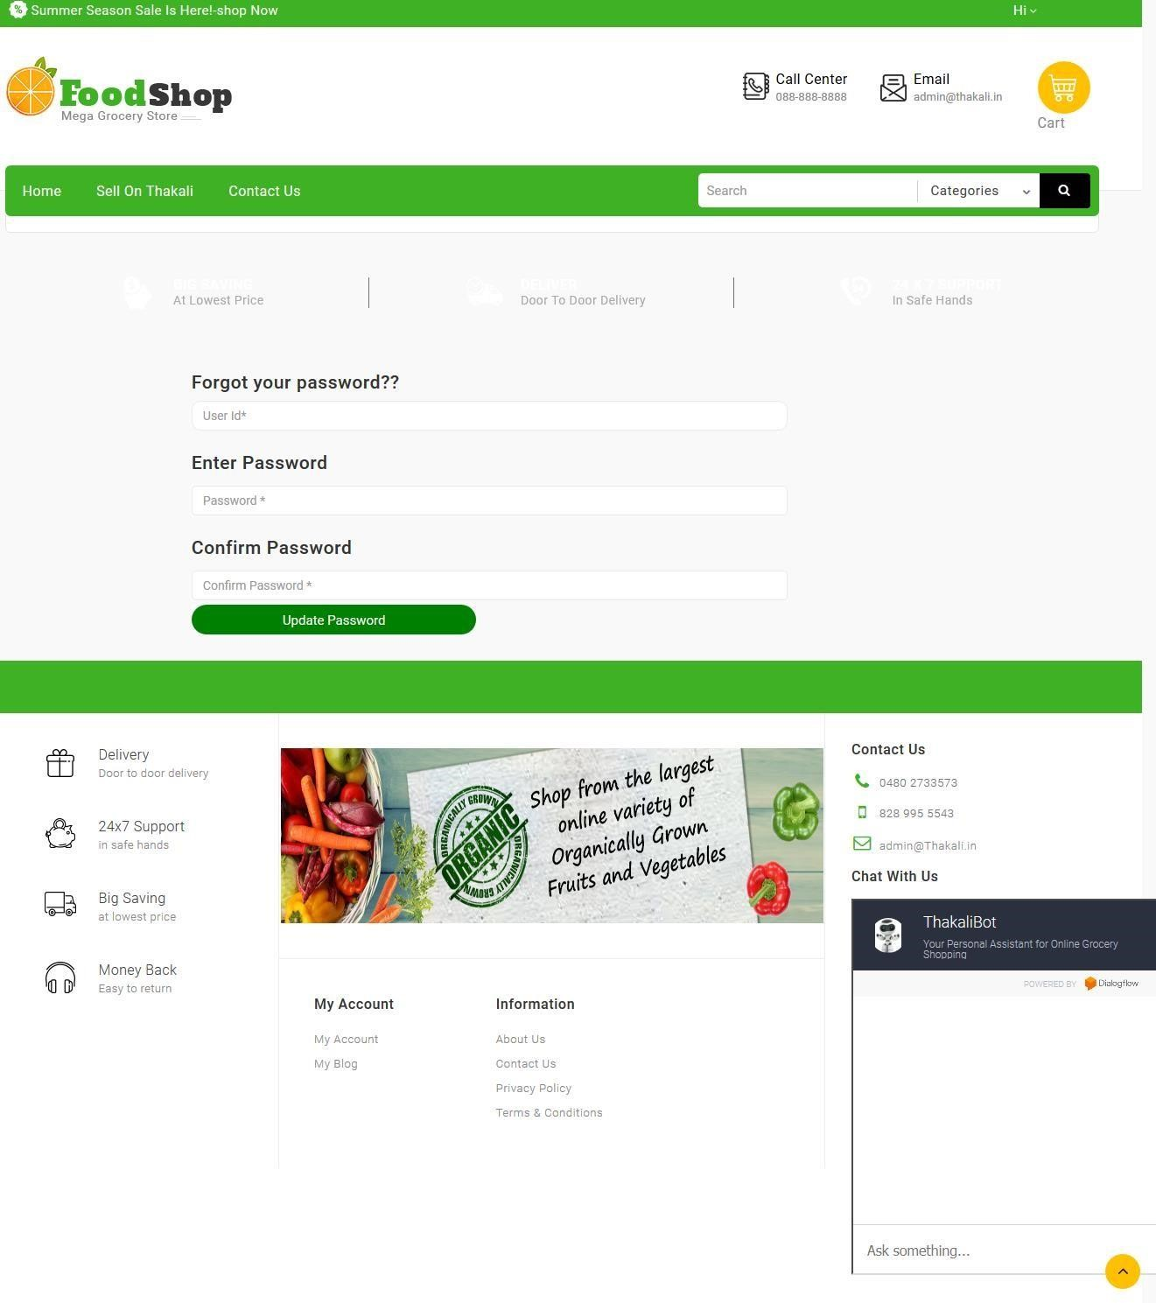

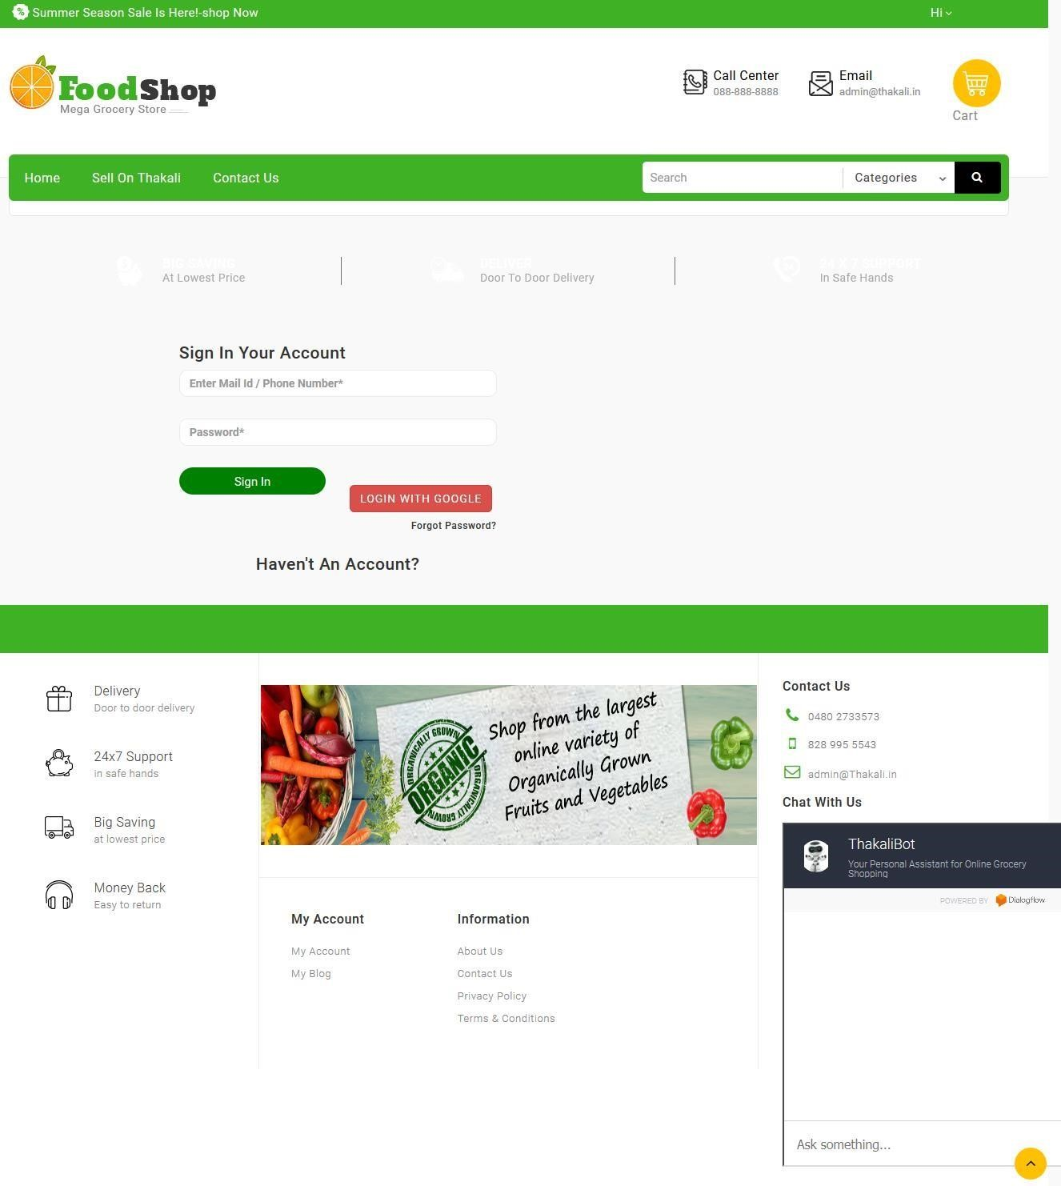

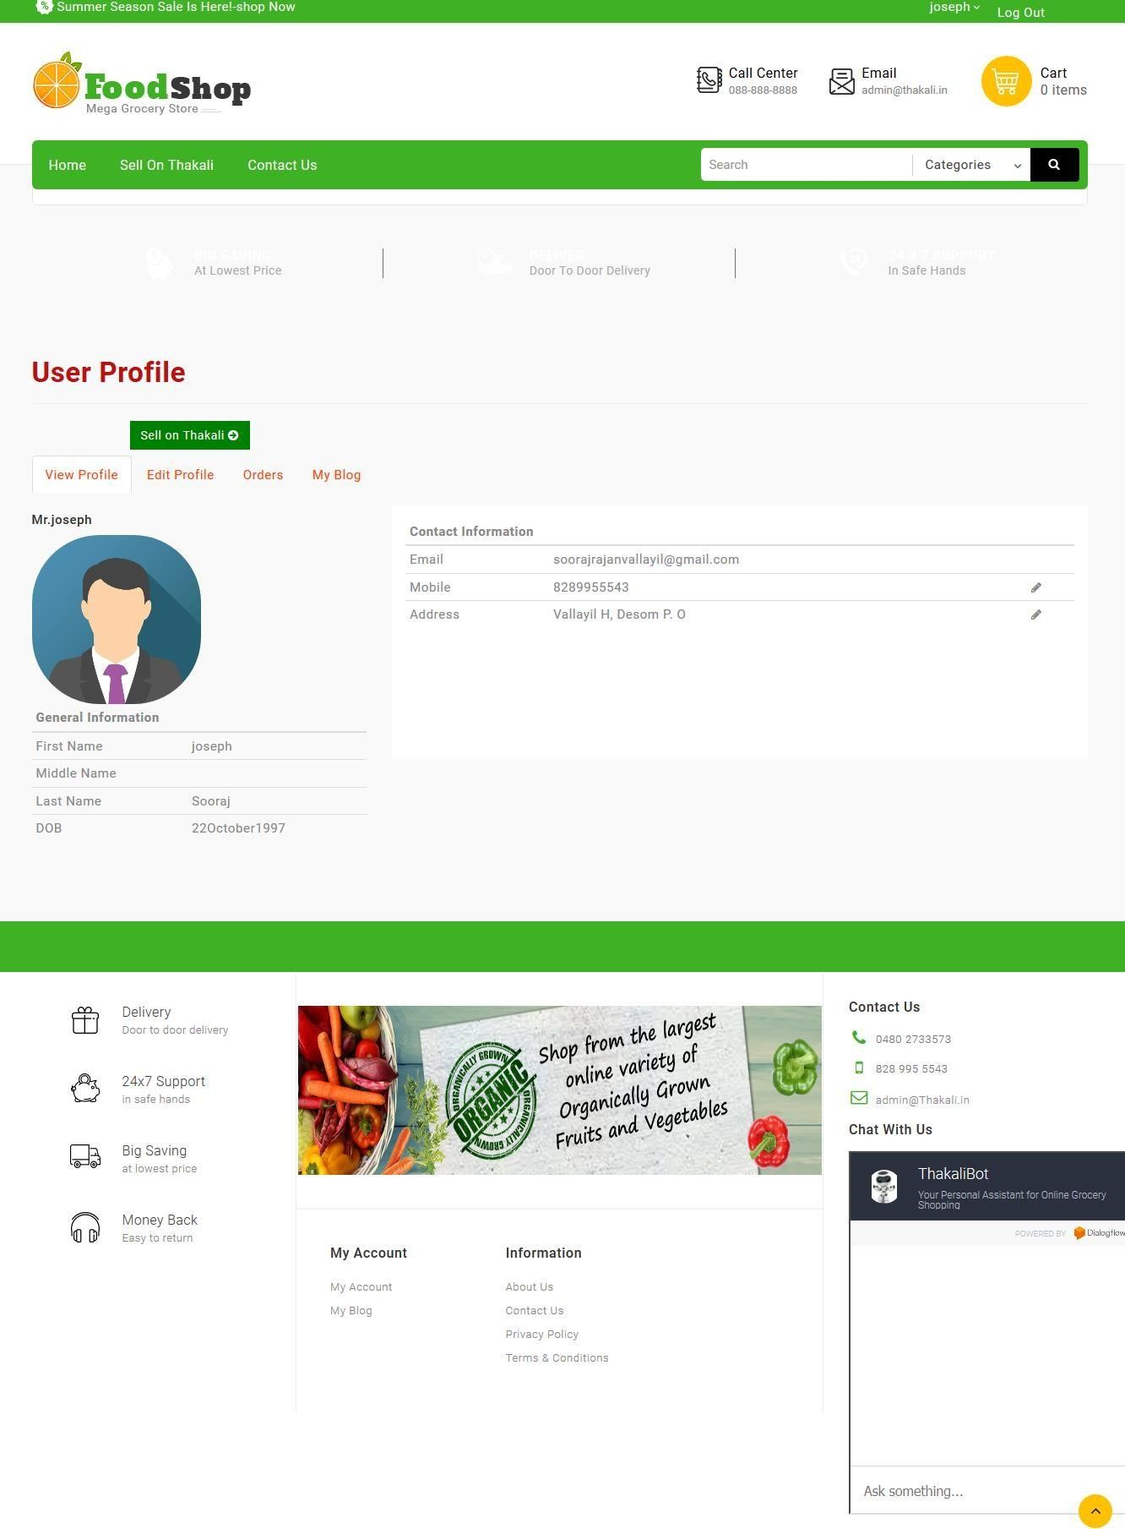

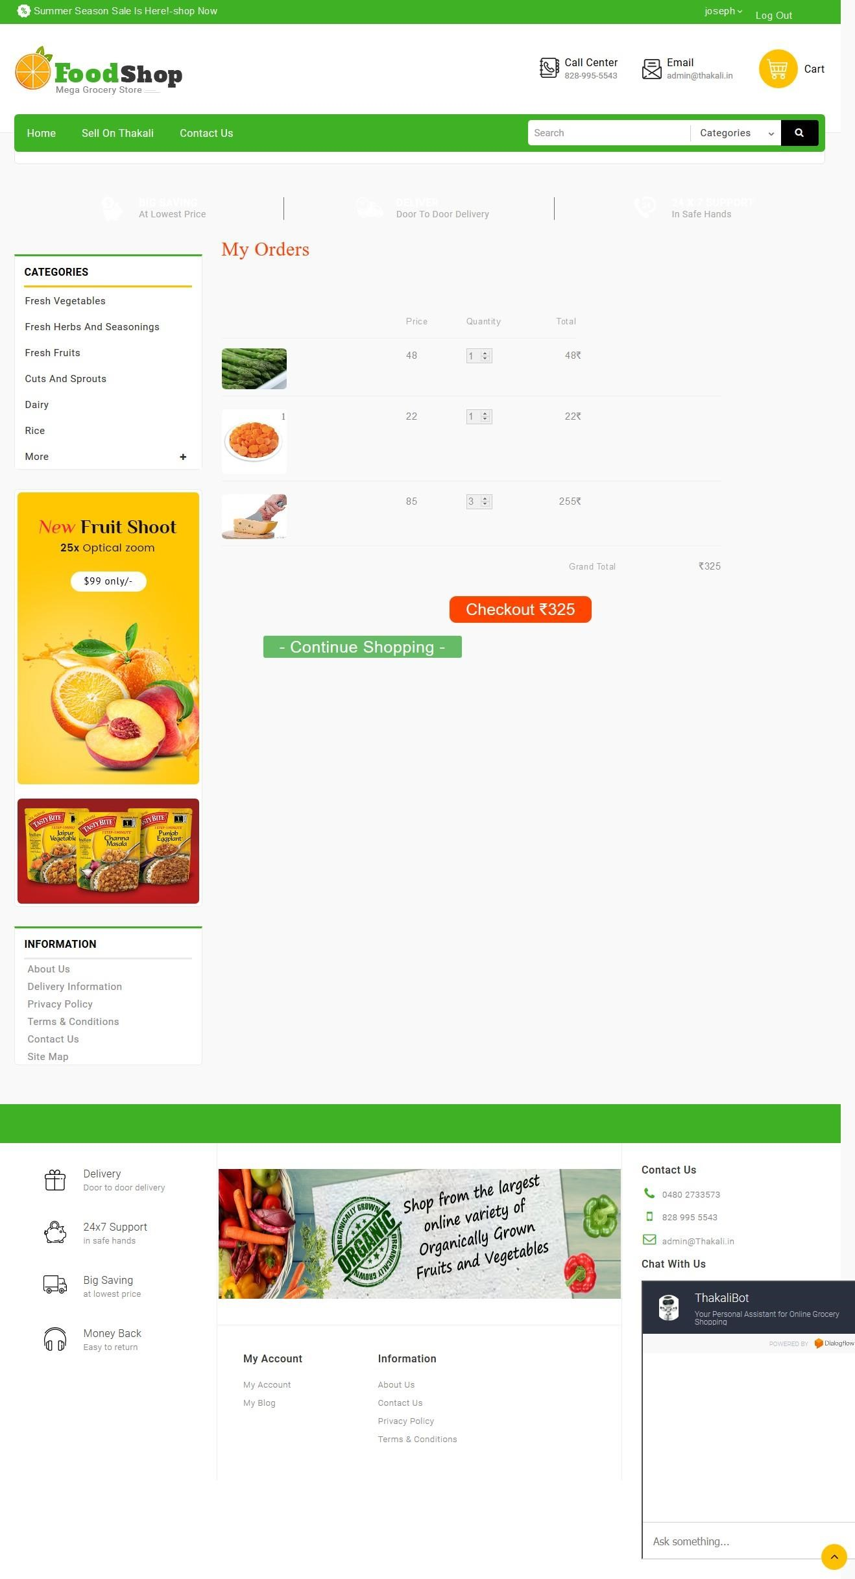

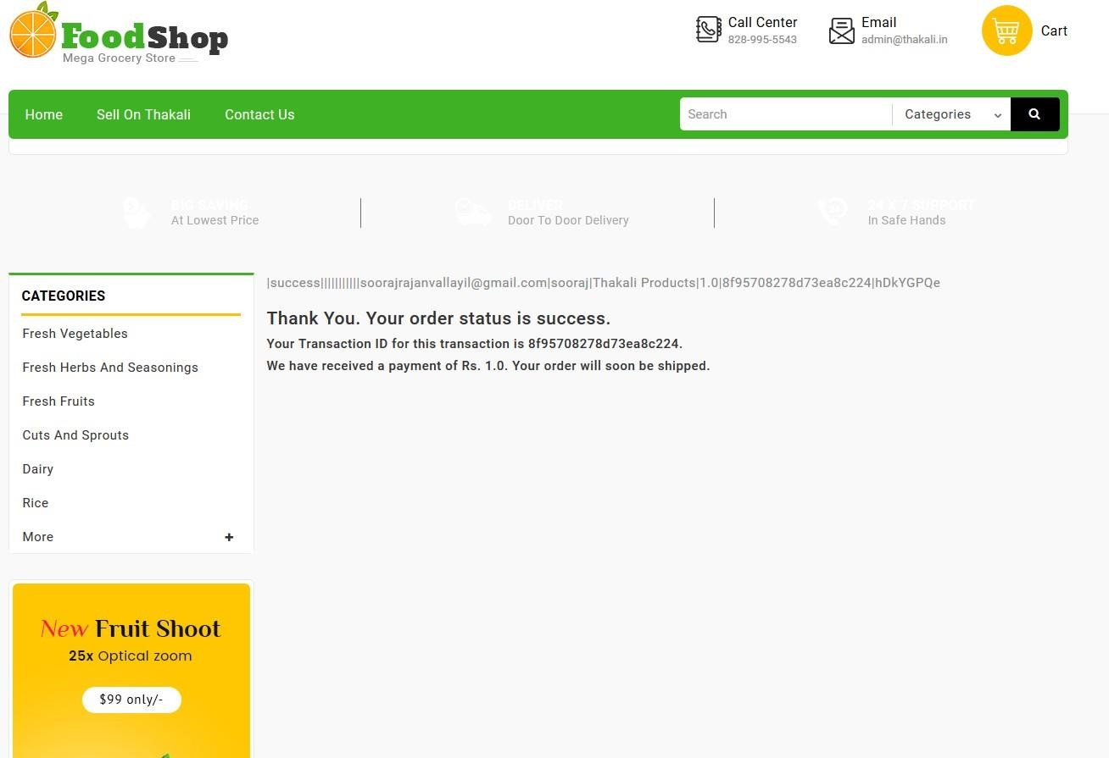

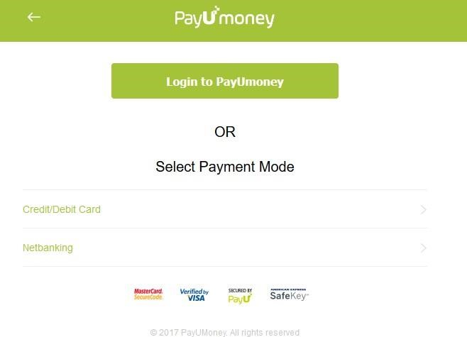

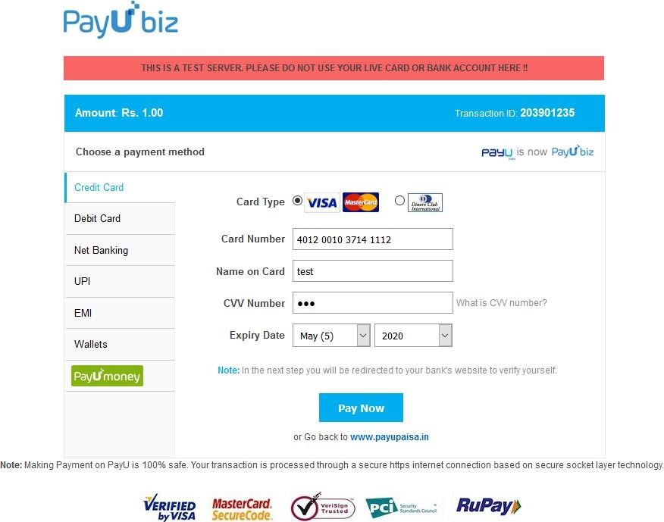

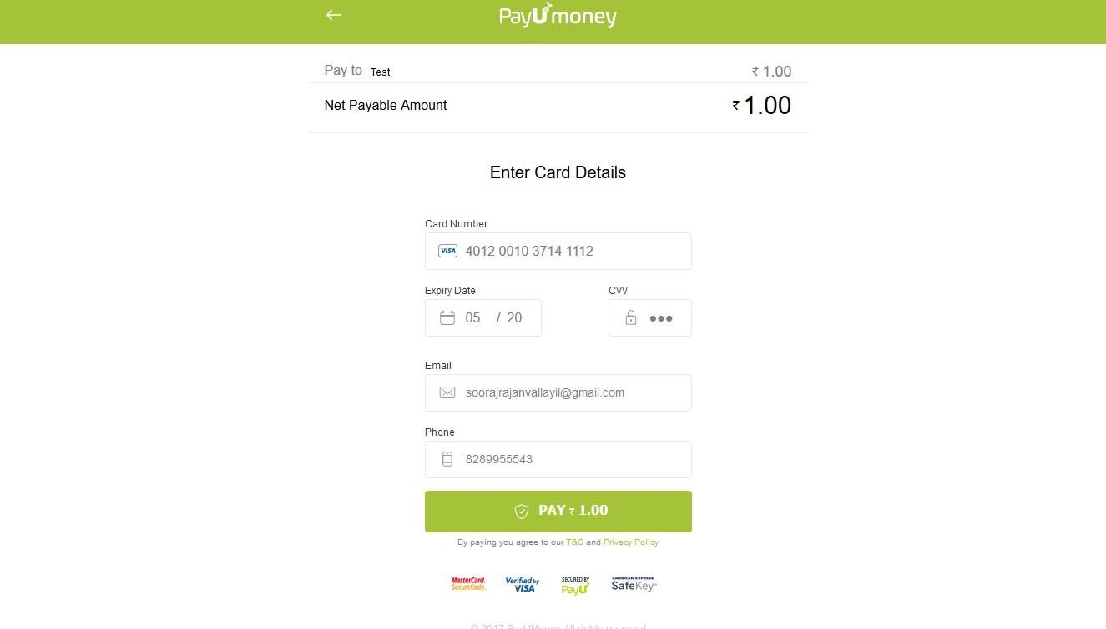

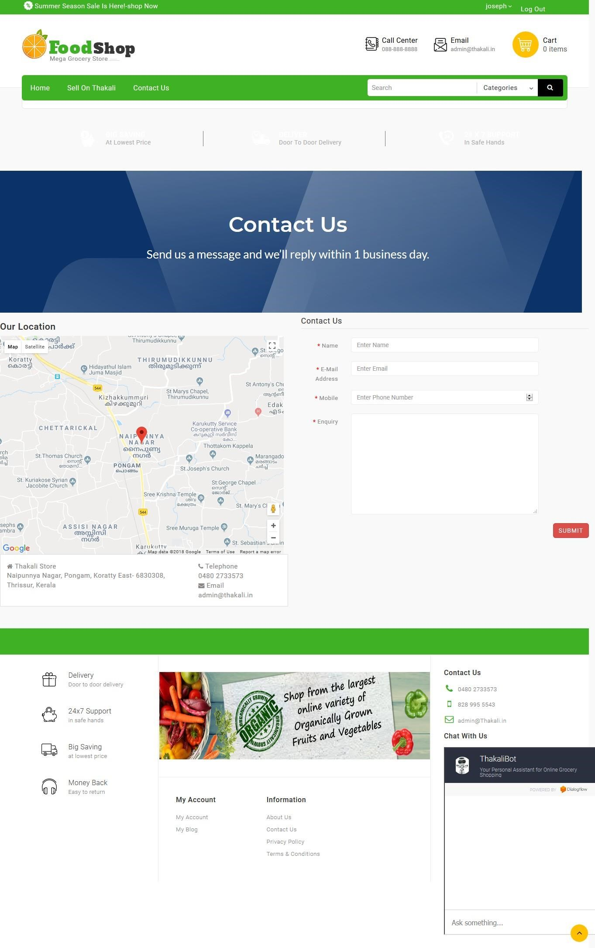

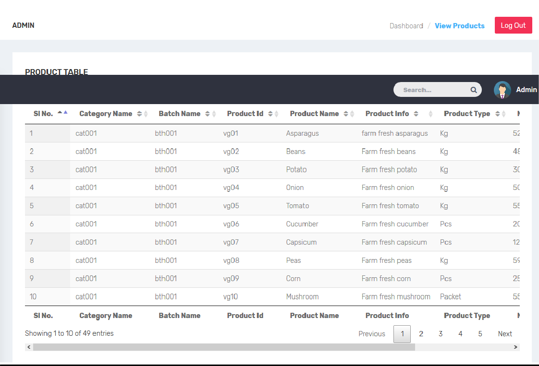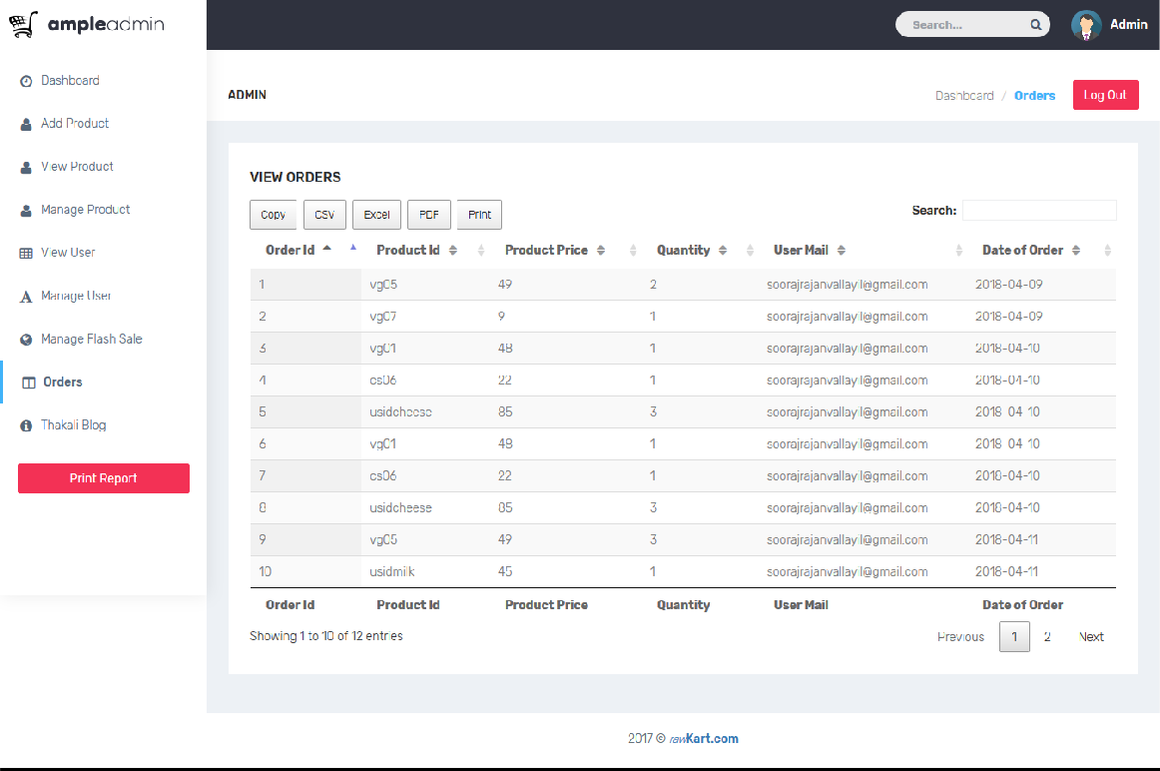

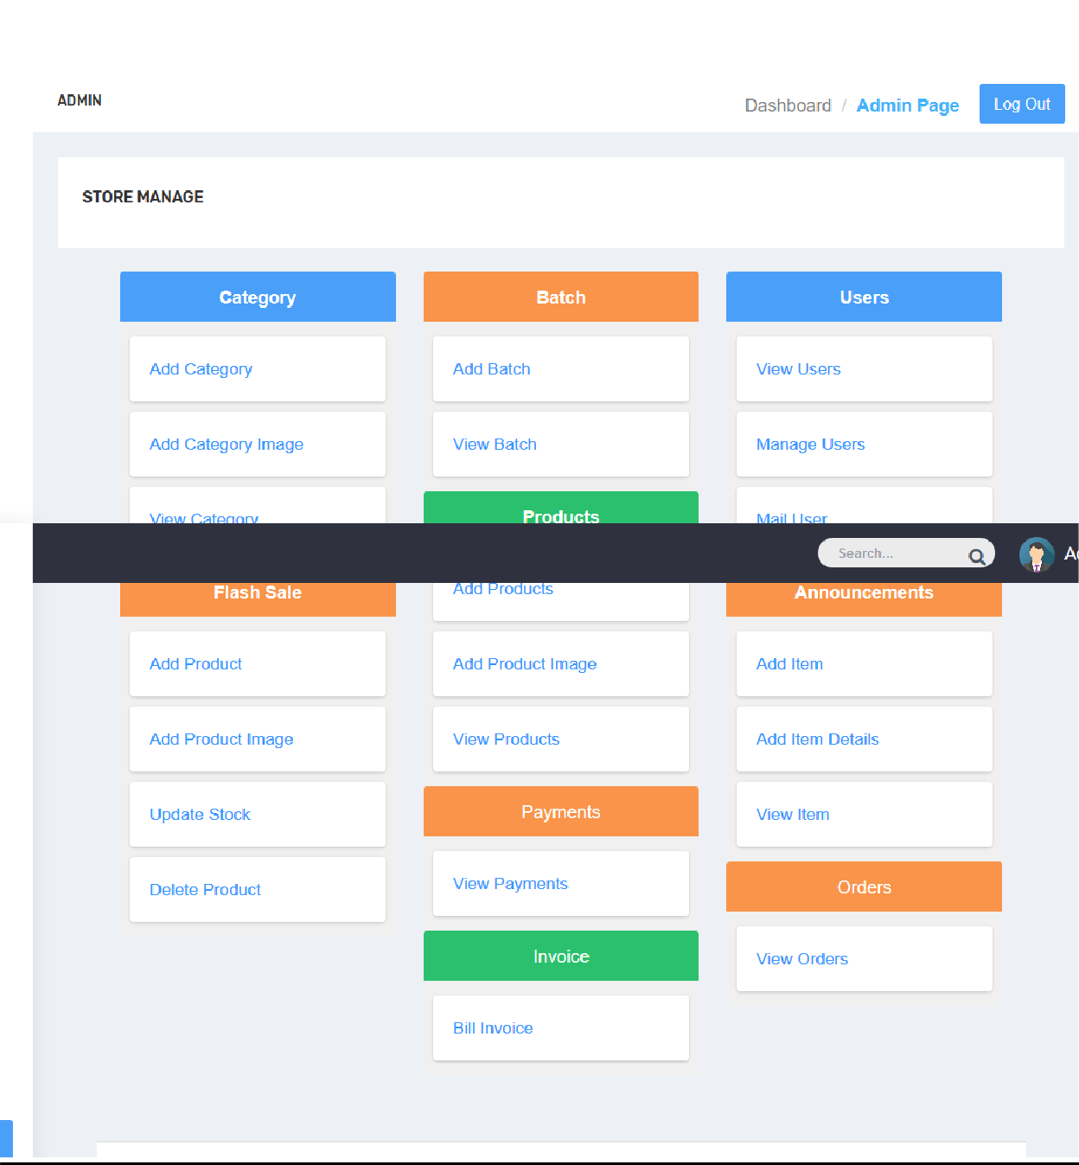

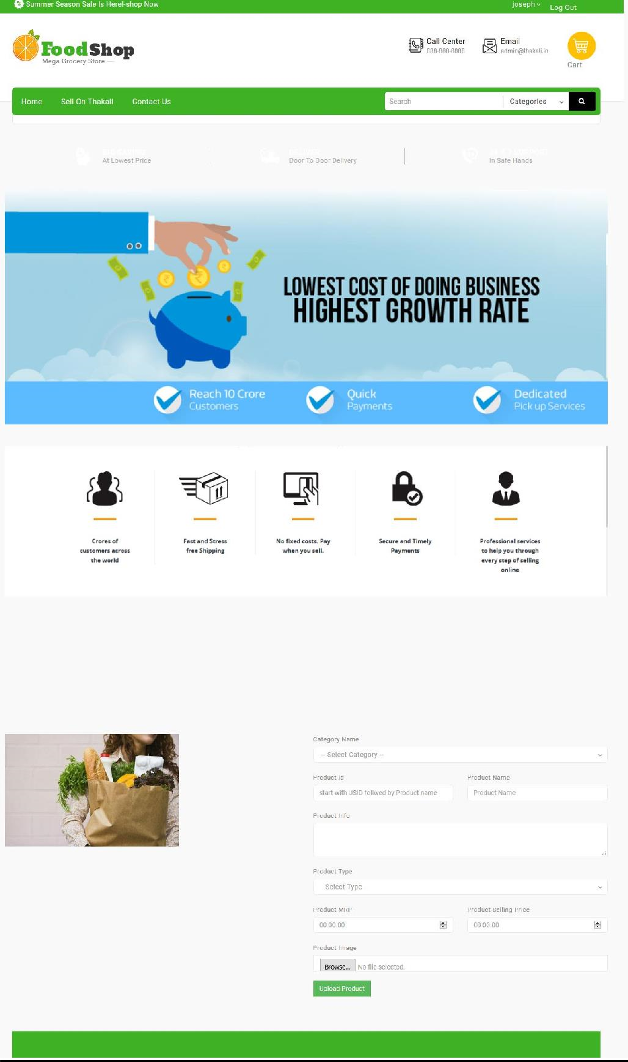

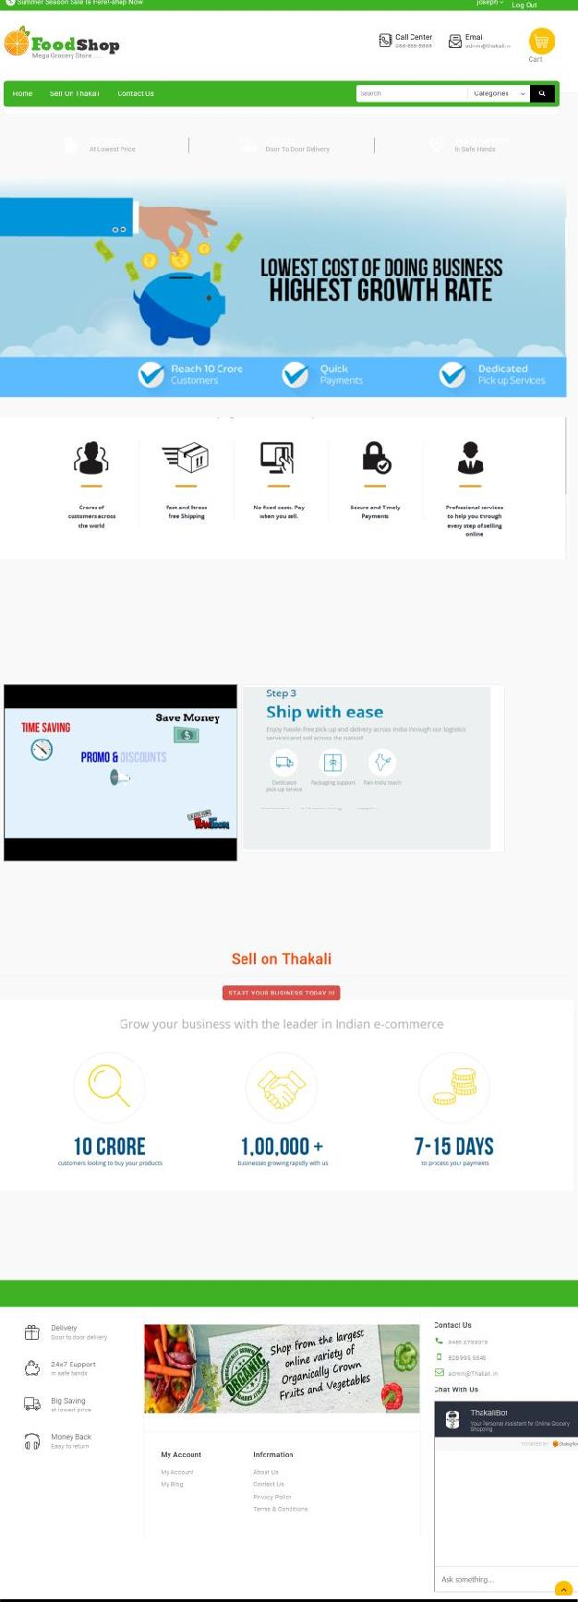

# **8.** CONCLUSION

The project entitled Online shopping system was completed successfully. The system has been developed with much care and free of errors and at the same time it is efficient and less time consuming. The purpose of this project was to develop a web application and an android application for purchasing items from a shop. This project helped us in gaining valuable information and practical knowledge on several topics like designing web pages using html & css, usage of responsive templates, designing of android applications, and management of database using MySQL. The entire system is secured. Also the project helped us understanding about the development phases of a project and software development life cycle. We learned how to test different features of a project. This project has given us great satisfaction in having designed an application which can be implemented to any nearby shops or branded shops selling various kinds of products by simple modifications. There is a scope for further development in our project to a great extent. A number of features can be added to this system in future like providing moderator more control over products so that each moderator can maintain their own products. Another feature we wished to implement was providing classes for customers so that different offers can be given to each class. System may keep track of history of purchases of each customer and provide suggestions based on their history. These features could have implemented unless the time did not limited us.

# **9.** BIBLIOGRAPHY

## REFERENCES

### 9.1 BOOKS

○ “Software Engineering Concept”, Richard Fairly, Tata McGraw-Hill 2nd edition

○ “System Analysis And Design” Elias M. Award Special Indian Edition

### 9.2 WEBSITES

○ [www.w3schools.com](http://www.w3schools.com/)

○ [www.php.net](http://www.php.net/)

○ [www.wikipedia.org](http://www.wikipedia.org/)